**Computer Organization and Architecture**

**Post-Lab**

**Lab 08**



|  |  |
| --- | --- |
| Group Members Name & Reg #: | **Muhammad Haris Irfan**  **(FA18-BCE-090)** |
|  |  |
| Class | Computer Organization and Architecture CPE343(**BCE-5B**) |
| Instructor’s Name | Dr. Adeel Israr |

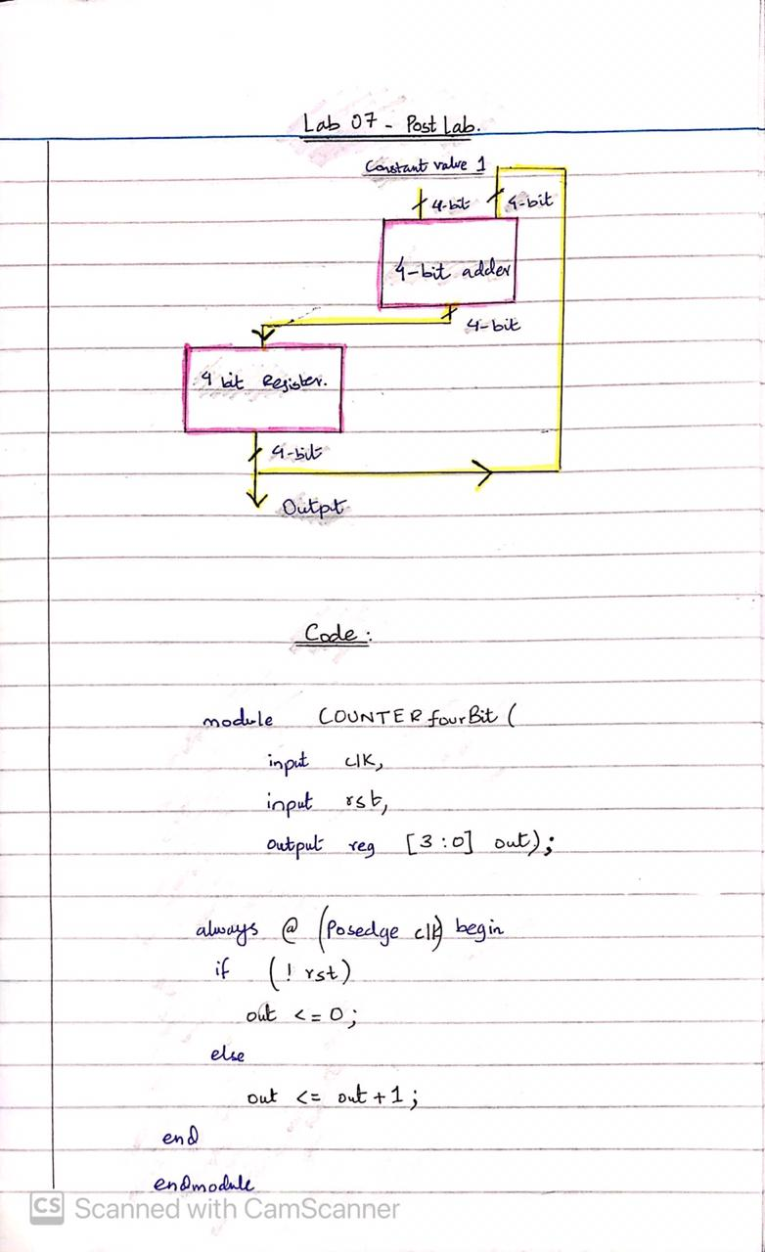**Inlab: Task 1**

**Task1 Output Waveform:**



